How to Use New Ad Hoc Form for Consults

Step 1: Find Ad Hoc button on the top banner in First Net or Power Chart

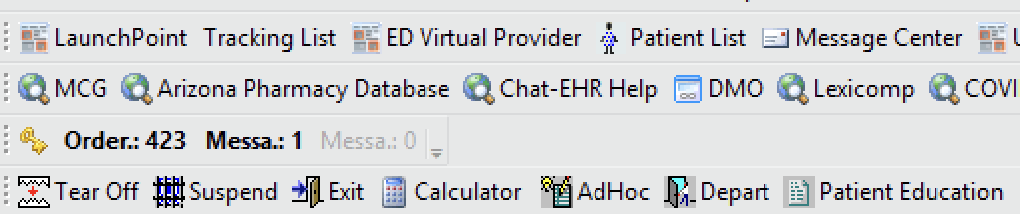

Step 2: In Physician Folder, Choose: Provider Consult Recommendation on bottom right

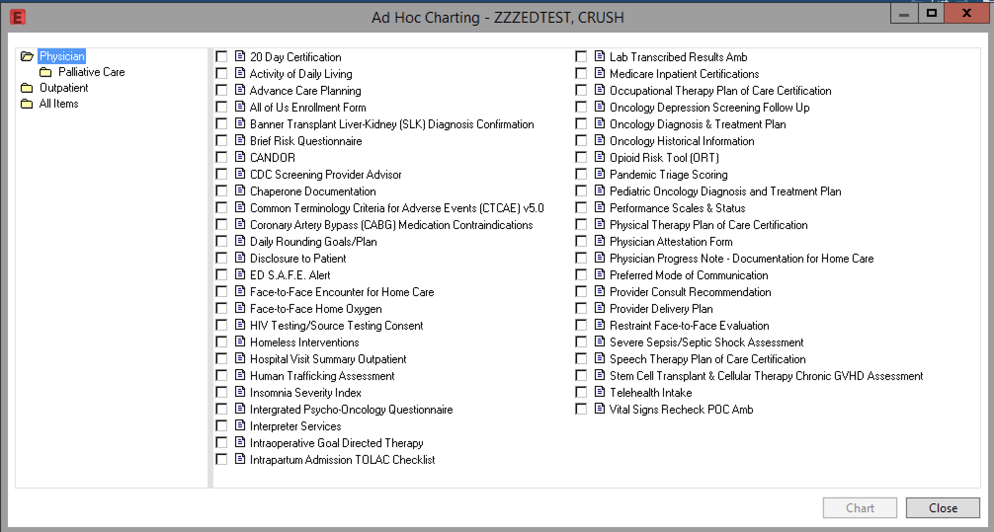

Step 3: Complete Consult Recommendation Ad Hoc

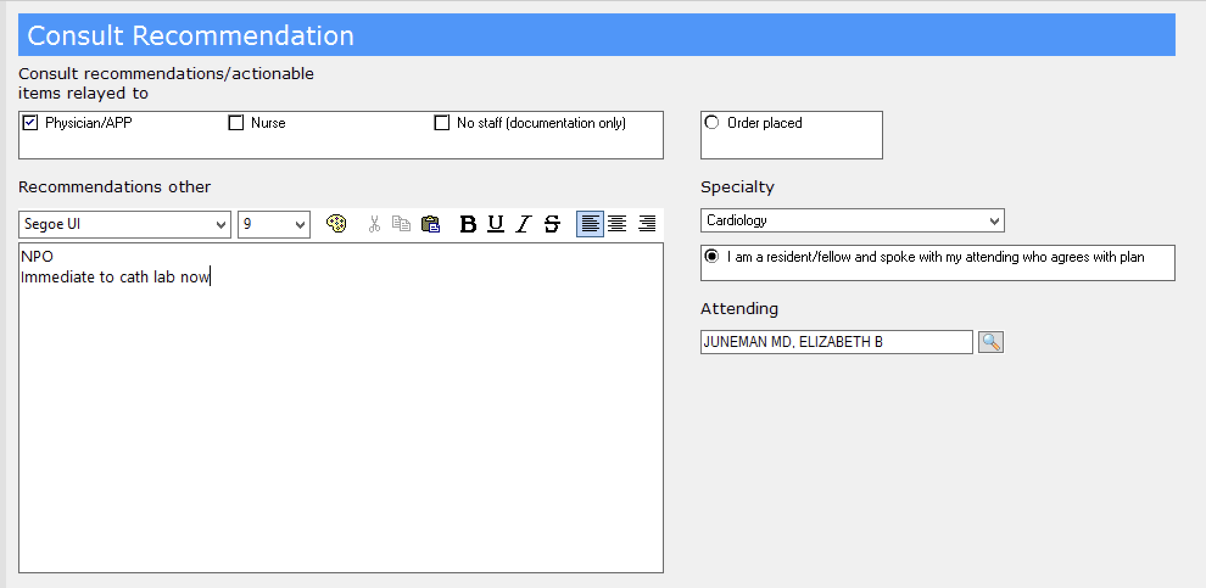
EXAMPLE ONLY

**Do not have to hit radio button if DCed prior to staffing with attending.

Step 4: Once signed, your brief consult note will populate into Cerner

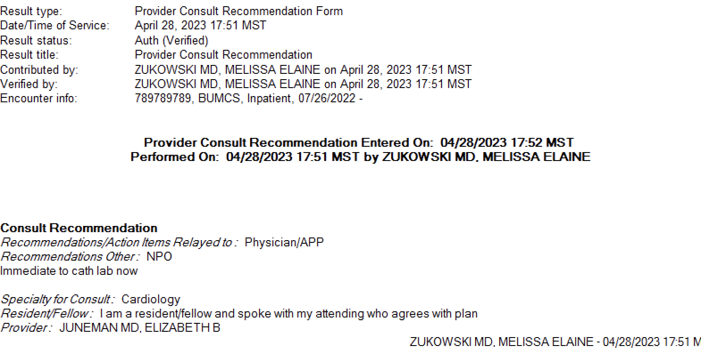
EXAMPLE ONLY

